**Important Links and Other Documentation**

User Story: <https://miro.com/welcomeonboard/qWSKUxH67l3hRjJd05q8yKW6UsNqXs1Th3ze8zuOpRjCJKj2z8dVY0CaDN4Uzk3T>  
  
Basic MoodBoard (look in Extended for a MUCH bigger moodboard) :

<http://www.gomoodboard.com/boards/1rX1cubC/share>

Rough Level Design:   
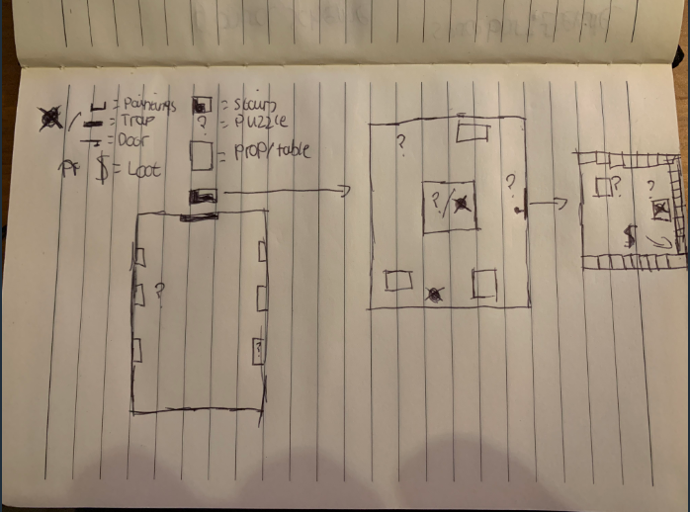

Choice of Mood board pictures

The theme of my escape room has been chosen as a heist room, there will be multiple rooms full of traps and puzzles where the player will get a unique prize like no other as a prize. The lighting will be 100% artificial as there is not supposed to be any windows or see through panels in a safe room. All the technology will be modernised with no scratches or blemishes since everything has to be up to date when holding treasure so dear or important to someone. When it comes to sound, there will be many mechanical noises when interacting with the props and especially when going through the safe doors. There will a continuous hum from vents and machines.

There really weren’t many pictures of a heist escape room or a secret room filled with puzzles which leaves my mind full of options on how I could do this.

Puzzles in The Grand Heist Escape Room

These puzzles have been decided to be put into the escape room but the order of appearance has not been decided yet.

1. The Trick Painting – There is a massive painting with a button on it that stands out but if you press the button then the alarm is raised. There is another painting that is the same size as the majority of paintings also has a button which will unlock the entrance to the room before the main treasure room.
2. The Safe Room Door – The safe room door can only be accessed through a keyword that is related to the person/company you are robbing.
3. Clues around the room – There will be clues around the room to what the keyword might be but the clues are locked behind other puzzles.
4. Algebra equation – The person/organisation who is being robbed is a big fan of maths, Algebra in particular so working out a few equations will unlock on of the first clues to the keyword.
5. Different lights, Revealing Sights – there are two different switches on the wall that lead to the main ceiling lights. When you enter the room, the light will automatically turn on but the lights control the sensitivity of the light which might reveal something on the wall that can be revealed in lower light.
6. Riddler – The person/organisation likes riddles along with maths; a few riddles will help with the puzzles hiding the clues.
7. Story time – You may have guessed but the clues around the room actually create a story of who you are robbing and maybe why you are robbing them. The story reveals what the keyword will be and will lead to the final puzzle in the treasury room.  
     
   8. Treasury Room – the last room after finding the keyword for the safe room will be filled with many bank lockers labelled with numbers. Picking the wrong one will reveal the alarm but picking the right one will reveal what you have been searching for.